Scope of Contest
Contestants will be tested on skills required in the "front of the house" of a fine restaurant. The focus is sanitation, table set up, napkin folding, understanding the steps of service, and overall presentation.
Students should wear the SkillsUSA Uniform with proper grooming & hygiene, follow ServSafe standards. These are evaluation areas.

Important Information
- Orientation attendance is mandatory.
- Menu will be provided at orientation.
- Specific table setting format will be provided prior to competition.
- Refer to National Technical Standards for contest detail and preparation for State/Nationals.

Contest Description
Task #1: Appearance/Uniform, Sanitation, Table-Setting, Napkin Folds (20 min) (30% of score):
- Table-setting: Set 3 formal place settings.
- Use ServSafe sanitization standards.
    - All settings must be identical.
- Napkin Folds: Competitors will create 6 unique napkin folds
  - 3 of the folds will be used as part of the table setting and the others will be set on an empty “seat” area on the table.
  - Napkin folds need to have labels with their proper names.
Task #2: Steps of Service (20 min) (45% of score)
      - Hosting: Competitor will host guest to table
      - Service: Competitors will serve 2+ courses to “guest(s)”.
    - Guest is not judge.
        - Menu will be provided the morning of competition.
        - Students will “serve” 2 courses from the menu to the guest using pretend food, but actual correct dishware i.e., soup in a bowl, salad on small place, etc...
        - Students will be expected to answer question(s) asked by the guest related to the menu.
          - Students are expected to perform all the steps of service.
      - Check Calculation: Using the “food” ordered by the guest to determine pricing, students will calculate a guest check, including tax and gratuity.
  - Guest check form will be provided for standardization purposes.
  - Guest check should be filled out, just as if competitor were handing check to guest at a real restaurant.
  - Tax Rate 8.26%
  - Gratuity 22%
Task #3: Tableside item (15 min) (25% of score): Tableside Caesar Salad
This is performed in a similar style to the Job Demonstration A contest.
    - Timeline: 3 min set up, maximum 10 min presentation, 2 min clean up.
    - Competitors will make the item from scratch in front of judge.
    - Mise en place should be completed prior to beginning competition.
    - Mise en place, sanitation, efficiency, and clean up are part of the score.

Service Equipment to be provided by CONTESTANT
- All ingredients necessary to create the Table Side Item. Ingredients can be premeasured.
- Bowl to mix ingredients, i.e, wooden bowl or other FOH mixing bowl based on item chosen to create.
- Any utensils needed to create tableside item, i.e. knife, forks, etc.
- Small plates/bowls to serve your item to the judges. 1 to serve, 1 to display.
- Crumber
- Linen for Napkin Folds
- Calculator (not programable)
- Sani Buckets & Cloth
- Polishing Cloth (different than the cloth used for sanitation)
- Pen(s)
- Waiters Book / Guest Check Presenter
- Small tray (drinks)
- Any other items necessary to complete the scope of the competition. Please see National Technical Standards for a comprehensive list of items needed for contest.
Service Equipment to be provided by SkillsUSA
- Tables
- Chairs
- Silverware
- Large Trays
- Glassware
- Guest Checks
- Menu – Provided at Orientation.
Scorecards: The National score sheets will be used to evaluate competitors
Table Setting Guideline
The students will duplicate this place setting with the following exceptions: 1 spoon only on the right side, dinner plate will not be set on the table. Napkins will be placed where the dinner plate is shown in the image.

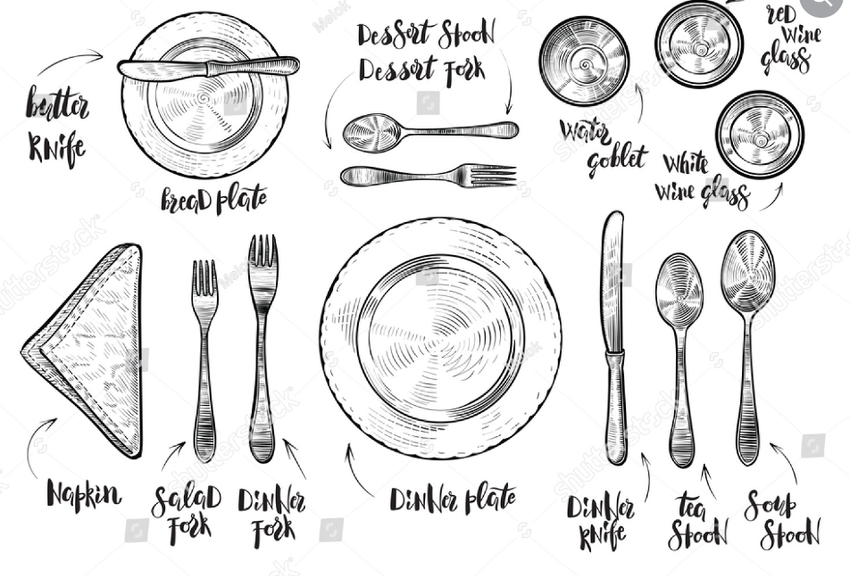
Tableside Item
- Make for 2 people
- Bring all ingredients for YOUR recipe, cut and in small containers ready for competition. (You can mise early)
- Be creative and have fun with this part.
- Taste is no more than 25 points, the remaining points are showmanship, sanitation, and waste.

Recipe ideas:
Guacamole
Caesar Salad

The recipes are for inspiration. Since you are providing the ingredients & mise, you can be creative in this area.

