Scope of Contest
Contestants will be tested on skills required in the "front of the house" of a fine restaurant. The focus is sanitation, table set up, napkin folding, understanding the steps of service, and overall presentation.
Students should wear the SkillsUSA Uniform with proper grooming & hygiene, follow ServSafe standards. These are evaluation areas.

Important Information
- Orientation attendance is mandatory.
- Menu will be provided at orientation.
- Specific table setting format will be provided prior to competition.
- Refer to National Technical Standards for contest detail and preparation for State/Nationals.

Contest Description
Task #1: Appearance/Uniform, Sanitation, Table-Setting, Napkin Folds (20 min) (30% of score):
- Table-setting: Set 3 formal place settings.
- Use ServSafe sanitization standards.
    - All settings must be identical.
- Napkin Folds: Competitors will create 6 unique napkin folds
  - 3 of the folds will be used as part of the table setting and the others will be set on an empty “seat” area on the table.
  - Napkin folds need to have labels with their proper names.
Task #2: Steps of Service (20 min) (45% of score)
      - Hosting: Competitor will host guest to table
      - Service: Competitors will serve 2+ courses to “guest(s)”.
    - Guest is not judge.
        - Menu will be provided the morning of competition.
        - Students will “serve” 2 courses from the menu to the guest using pretend food, but actual correct dishware i.e., soup in a bowl, salad on small place, etc...
        - Students will be expected to answer question(s) asked by the guest related to the menu.
          - Students are expected to perform all the steps of service.
      - Check Calculation: Using the “food” ordered by the guest to determine pricing, students will calculate a guest check, including tax and gratuity.
  - Form will be provided for standardization purposes.
  - Guest check should be filled out, just as if competitor were handing check to guest at a real restaurant.
  - Tax Rate 8.25%
  - Gratuity 18%
Task #3: Tableside item (15 min) (25% of score): Tableside Caesar Salad
This is performed in a similar style to the Job Demonstration A contest.
    - Timeline: 3 min set up, 10 min presentation, 2 min clean up.
    - You will make the item from scratch in front of judge.
    - Mise en place should be completed prior to beginning competition.
    - Mise en place, sanitation, efficiency, and clean up are part of the score.
Scorecards
The National score sheets will be used to evaluate competitors

Service Equipment to be provided by CONTESTANT
- All ingredients necessary to create the Table Side Item. Ingredients can be premeasured.
- Bowl to mix ingredients, i.e, wooden bowl or other FOH mixing bowl
- Any utensils needed to create tableside item, i.e. knife, forks, etc.
- Crumber
- Linen for Napkin Folds
- Calculator
- Sani Buckets & Cloths
- Polishing Cloth
- Pen(s)
- Waiters Book / Guest Check Presenter
- Small tray (drinks)
- Any other items necessary to complete the scope of the competition. Please see National Technical Standards for a comprehensive list of items needed for contest.

Service Equipment to be provided by SkillsUSA
- Tables
- Chairs
- Silverware
- Large Trays
- Glassware
- Menu – Provided at Orientation.

Scorecards: The National score sheets will be used to evaluate competitors

Table Setting Guideline:
The students will duplicate this place setting with the following exceptions:

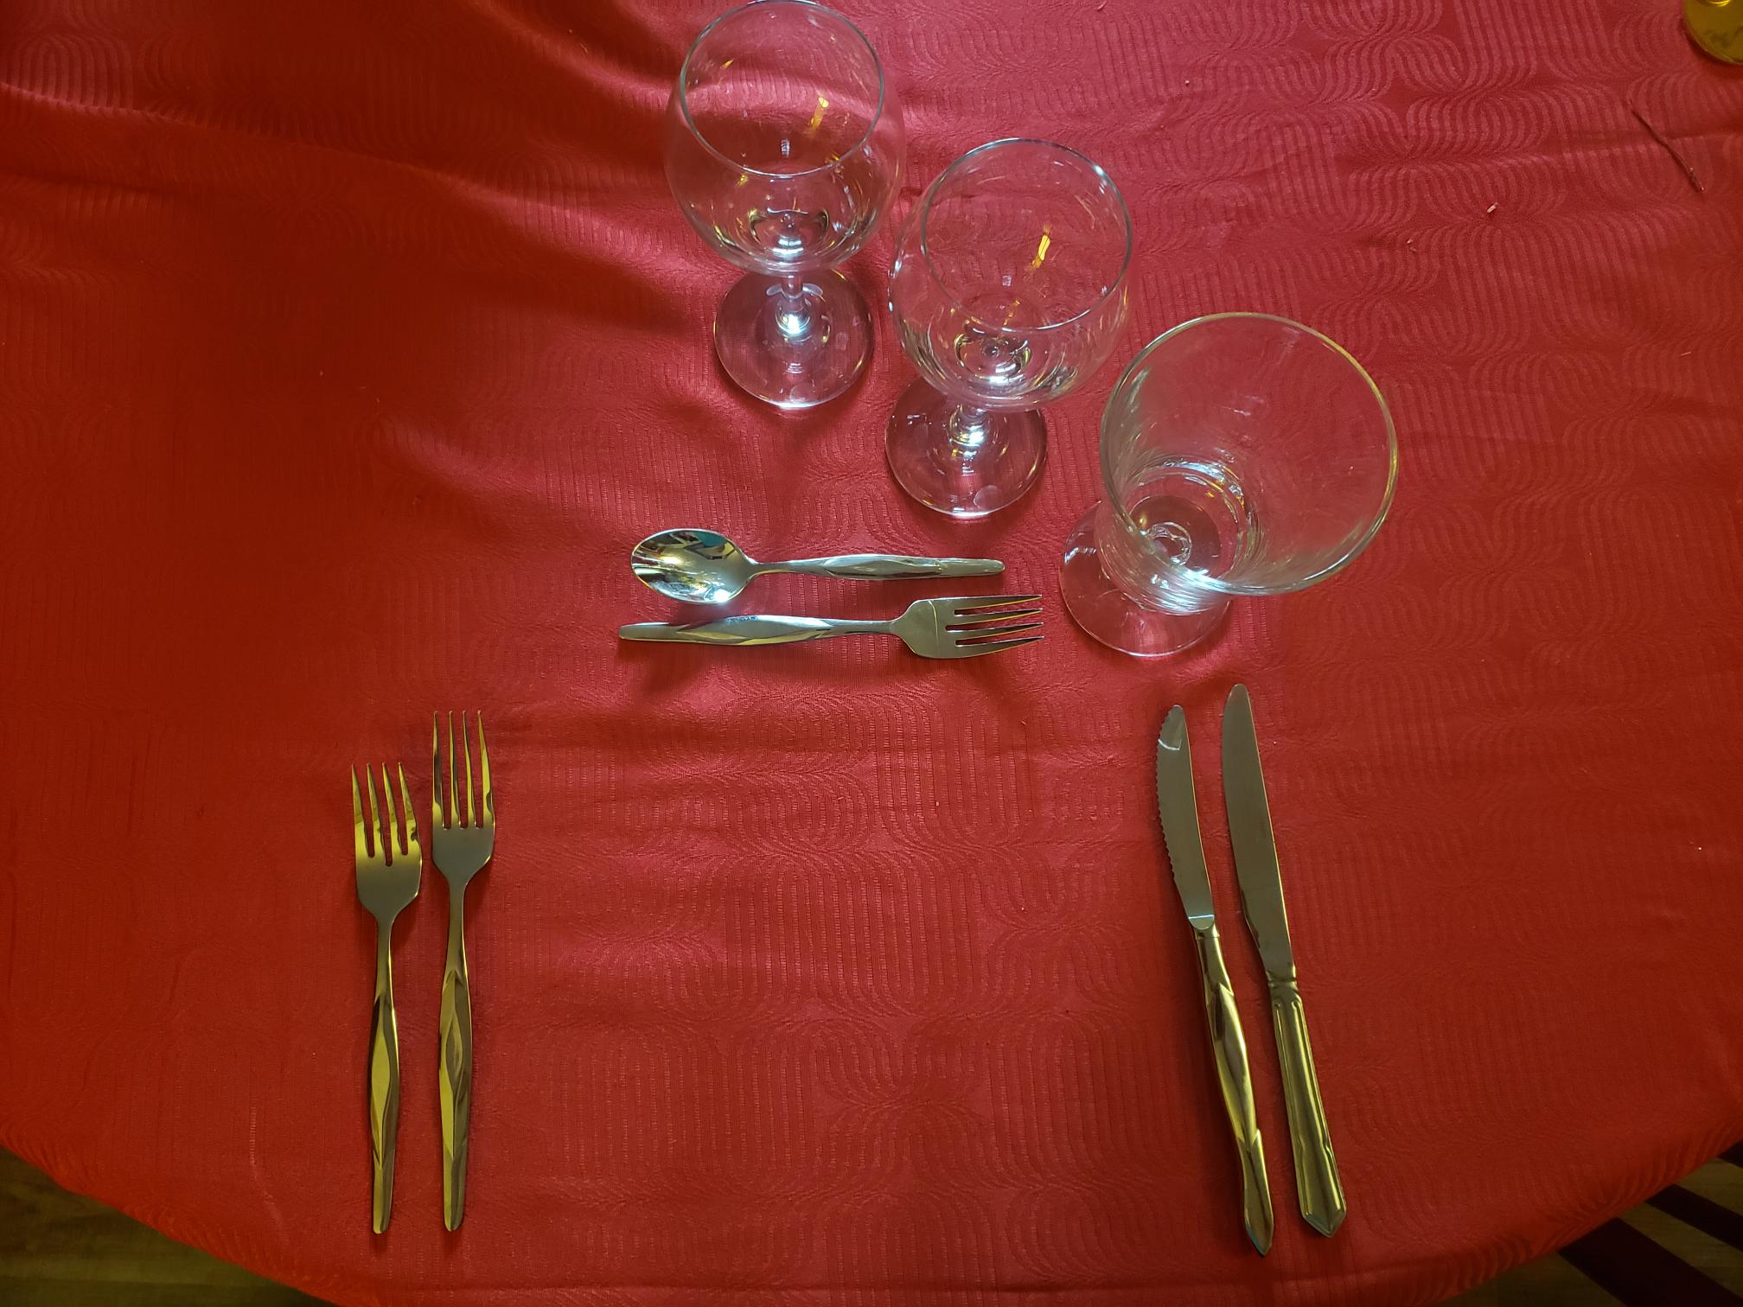

Tableside Item
- Make for 2 people
- Bring all ingredients for YOUR recipe, cut and in small containers ready for competition. (You can mise early)
- Be creative and have fun with this part.
- Taste is no more than 25 points, the remaining points are showmanship, sanitation, and waste.

Recipe ideas:
Guacamole
Caesar Salad

The recipes are for inspiration. Since you are providing the ingredients & mise, you can be creative in this area.

