DRAFTING SKILLS CONTESTS
Contest Update
2023

The SkillsUSA State Drafting Skills Contest will be at Del Mar College this year.
Del Mar College
OSC Creek Campus
7002 Yorktown Blvd
Corpus Christi, TX 78404

Del Mar College has computers you can use (see computer information for your contest) or you can bring your own.
Please Email: gklepac1@delmar.edu and copy dcwhittenburg@gmail.com if you are planning to bring your own computer so we can make sure to have room for it. Tell him which contest your student is in.

Make sure to read the Nationals Regulations and Texas Regulations for your contest.

Projects will still be at the ABC = American Bank Center. See the State Agenda for information.

For questions, please contact D.C. Whittenburg at dcwhittenburg@gmail.com.

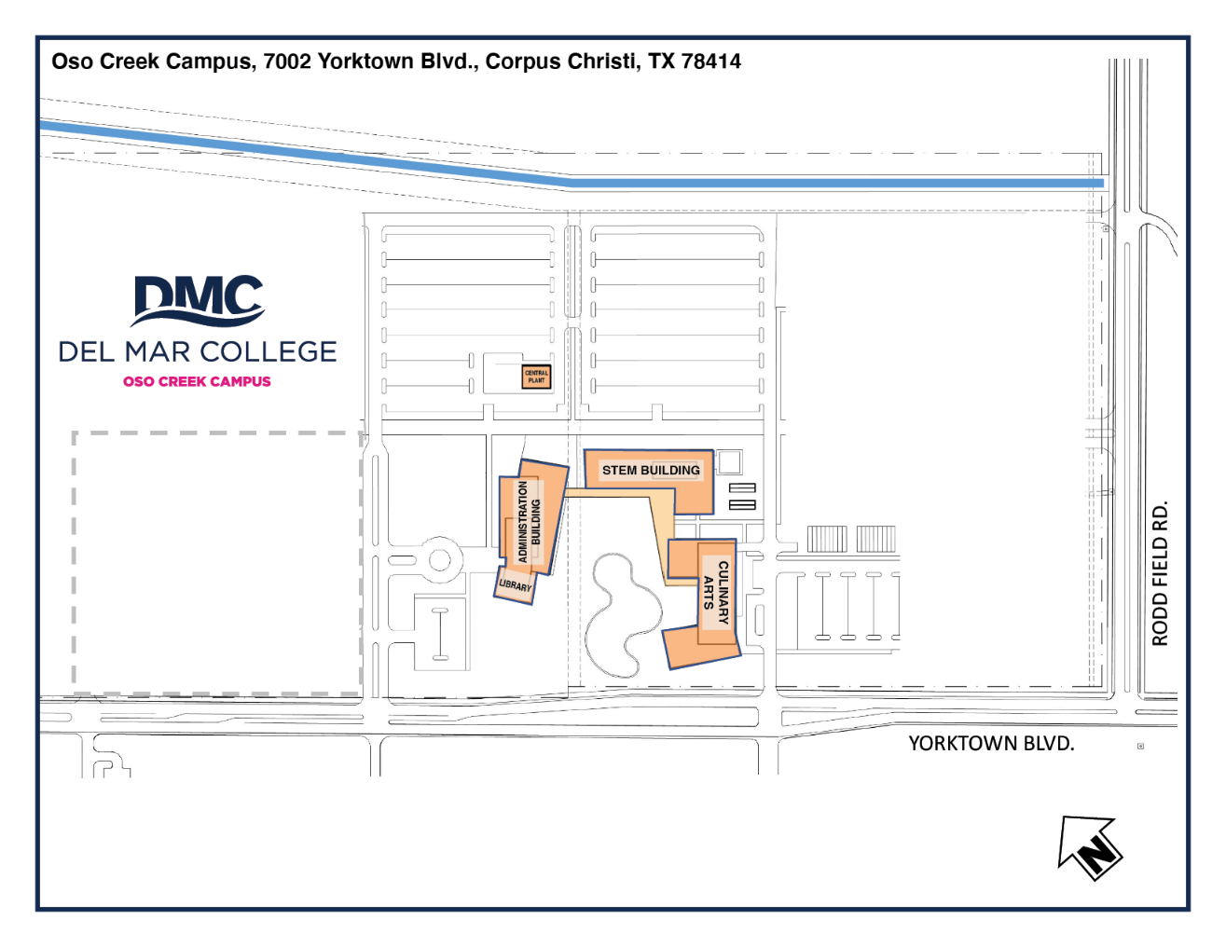
Personal Desktop or Laptop Area.

If you are bringing your own Laptop or Desktop, we will need to know prior to coming so that we can set up power options. You must bring your own power bar (Surge Protector with a min of a 6 ft cord).
Note: Make sure you can connect to the guest wfi. If, you need Internet.

Note: While we strive to have working computers, Hosting Center cannot be held responsible for malfunction and or missing contestant files. If a computer Malfunctions, we will replace computer as quickly as possible.

Clothing Requirements:
Class E: Competition Specific – Business Casual
- Official SkillsUSA white polo shirt
- Black dress slacks or black dress skirt (knee-length minimum)
- Black closed-toe dress shoes
Note: Wearing socks or hose is no longer required. If worn, socks must be black dress socks and hose must be either black or skin-tone and seamless/nonpattern.

Architectural Drafting Contest
(1st, 2nd and 3rd Place District Winners will compete in this Contest)
Rev 3/6/23

Orientation (Check the 2023 State Contest Schedule)
Location: ABC
Room: 101-102
Thursday, March 30, 2023
Orientation Time: 2:00
Note: Bring your Resume and something to write with.

Contest

Location: Del Mar College
Building: Stem
Room: ST112

Friday, March 31, 2023
Setup time: 8:00 AM
Contest time: 8:30 AM

Architectural Drafting (Equipment and Materials)
Computer Information:
Del Mar College has Computers with AutoDesk Revit 2022 on them, or you can bring your own Laptop or computer, monitor, input devices, CAD program of choice and a multi-receptacle power strip.

Supplied by the contestant
- Removable data device (Flash Drive).
- Be able to save the problem as a .pdf file format.
- School-owned computers must be set up to operate the CAD software independent of the school's network.
- Contestants are encouraged to bring published reference materials. The materials cannot be shared with other contestants nor exceed one cubic foot of space. (ARCHITECTURAL GRAPHIC STANDARDS is a recommended reference).
- Personal drafting supplies (i.e. scale dividers, pencil, eraser, and/or other layout devices).
- A one-page résumé (résumé will be collected at the contest orientation session).

Technical Drafting Contest
(1st, 2nd and 3rd Place District Winners will compete in this Contest)
Rev 3/6/23

Orientation (Check the 2023 State Contest Schedule)
Location: ABC
Room: 101 - 102
Thursday, March 30, 2023
Orientation Time: 2:00
Note: Bring your Resume and something to write with.

Contest

Location: Del Mar College
Building: Stem
Room: ST120

Friday, March 31, 2023
Setup time: 8:00 AM
Contest time: 8:30 AM

Technical Drafting (Equipment and Materials)
Computer Information:
Del Mar College has Computers with AutoDesk Inventor 2022 on them, or you can bring your own Laptop or computer, monitor, input devices, CAD program of choice and a multi-receptacle power strip.
Supplied by the contestant
- Removable data device (Flash Drive).
- Be able to save the problem as a .pdf file format.
- School-owned computers must be set up to operate the CAD software independent of the school's network.
- Contestants are encouraged to bring published reference materials. The materials cannot be shared with other contestants nor exceed one cubic foot of space. (MACHINERY’S HANDBOOK is a recommended reference).
- A one-page résumé (résumé will be collected at the contest orientation session).
- MACHINERY’S HANDBOOK (By Erik Oberg, Franklin D. Jones, Holbrook L. Horton, and Henry H. Ryffel)
Pub: Industrial Press New York, New York ISBM 978-083112801-2
The above is the preferred reference book to bring to contest.
You may bring this and/or other references as a published book, or as a PDF file on your system, or on a CD disk, or on a standalone flash-drive (not the one you will use for plotting)

AutoCAD Civil Design Contest
(1st, 2nd and 3rd Place District Winners will compete in this Contest)

Orientation and Contest

Location: Del Mar College
Building: Stem
Room: ST119

Friday, March 31, 2023
Setup time: 8:00 AM
Contest time: 9:00 AM

AutoCAD Civil Design (Equipment and Materials)

Computer Information:
You are required to bring your own Laptop or PC-type computer, monitor, input devices, CAD program of choice and a multi-receptacle power strip for this contest.

Supplied by the contestant
- Laptop or computer, monitor, input devices, a multi-receptacle power strip, AutoCAD program or CAD program of choice.
- Removable data device (Flash Drive).
- Be able to save the problem as a .pdf file format.
- School-owned computers must be set up to operate the CAD software independent of the school's network.
- Contestants are encouraged to bring published reference materials. The materials cannot be shared with other contestants nor exceed one cubic foot of space.
- A one-page résumé (résumé will be collected at the contest orientation session).

Mechanical Drafting Contest
(1st, 2nd and 3rd Place District Winners will compete in this Contest)

Orientation and Contest

Location: Del Mar College
Building: Stem
Room: ST128

Friday, March 31, 2023
Setup time: 8:00 AM
Contest time: 9:00 AM

Mechanical Drafting (Equipment and Materials)
Equipment Information:
Del Mar College, has tables but, you required to bring your supplies.

Supplied by the contestant
- Typical personal drafting equipment and supplies desired for traditional drafting.
- Contestants are encouraged to bring published reference materials. The materials cannot be shared with other contestants nor exceed one cubic foot of space.
- A one-page résumé (résumé will be collected at the contest orientation session).

