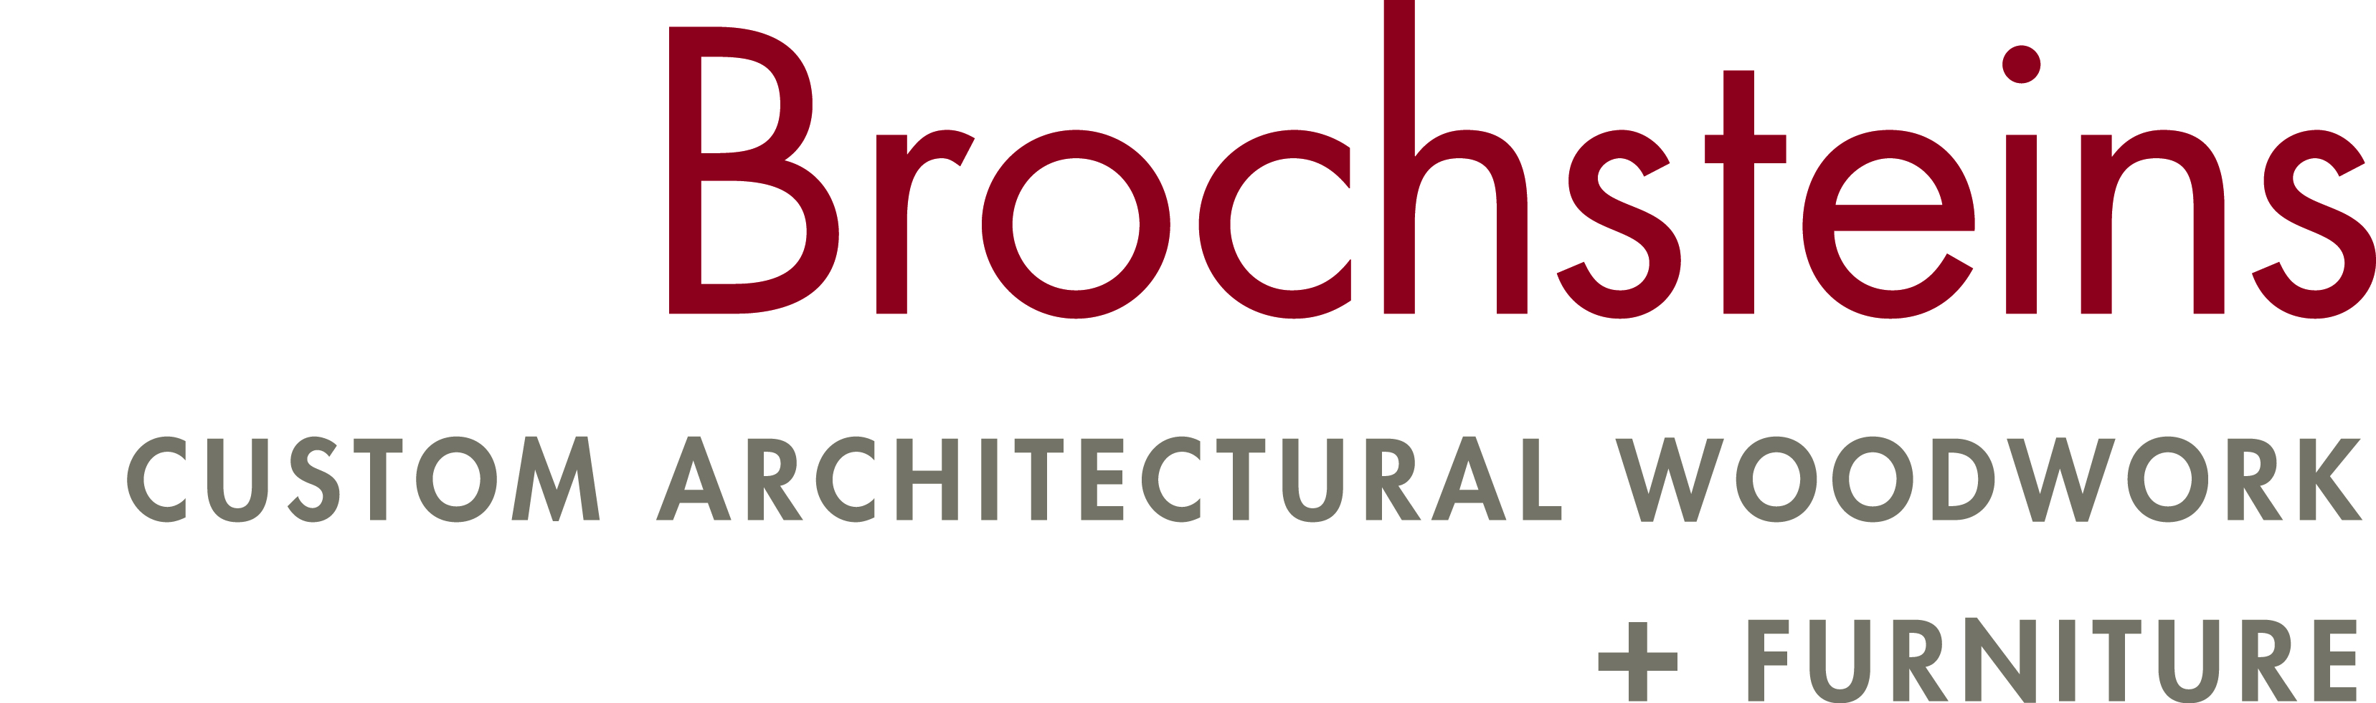

Re: Texas Skills/USA
State Cabinetmaking Skills Contest 3/15/23
Corpus Christi, Texas
March 31st & April 1st, 2023 American Bank Center Exhibit Hall

Dear Advisor,
I congratulate you and your student(s) on qualifying for the state contest. We appreciate sincerely the sponsorship of the Texas Architectural Woodwork Institute (TAWI) and Brochsteins inc. for the cabinetmaking contest. TAWI will again provide the prize for our first place finisher. Our First Place contestant will receive a voucher for reimbursement of travel and registration expenses for the National Skills USA contest in Atlanta Ga. 2023 will mark the 17th year that TAWI will be awarding 3 college/trade school scholarships. 9th Annual Charles Lutz Memorial $1500 first place scholarship, 4rd Annual Bob & Patsy Goebel Memorial $1000 2nd place scholarship and for the 1st time the Jose Roberto Elizalde Memorial $500 scholarship for 3rd place. Special thanks to Brochsteins Inc. for providing and coordinating the contest project. Above all we intend to conduct a first class competition and keep the students safety as our #1 priority

The TAWI Contest committee will provide all power equipment, including cordless drill, screw driver, battery powered nailer and sanders. Students should not bring any power or pneumatic tools. Contestants will be provided a Drill bit/Screw driver tip kit for use in the contest. Students are only permitted to bring tools as listed in the Skills USA list of tools, in addition contestants should bring 2- bar or pipe clamps 30-36” long,

All contestants are required to wear approved uniforms and submit a resume of no more than 1 page length. Type shall be 10pt minimum

Friday March 31st Mandatory Orientation and Written Test 1:30pm -2:30pm at CABINETMAKING booth in the Exhibit Hall, American Bank Center. Submit Resumes. Students may store their tool boxes in the booth for the contest. If your student has a conflict with the Orientation time please contact me ASAP.

Saturday, April 1st 8:00 A.M. CONTESTANT CHECK-IN, CLOTHING & EQUIPMENT INSPECTION.
Tool demonstration.

8:30am-2:30pm –Start Contest, lunch for contestants provided in booth.
2:30 PM Contest Ends, Clean up, Total scores.

SKILLS CONTEST WINNER WILL BE ANNOUNCED at 8:00pm Awards Ceremony Saturday 1st.

I look forward to seeing you,
Richard Shelley Cabinetmaking Contest Tech Chair Cell 832.423.2353 Richard.Shelley@brochsteins.com
Brochsteins Inc. 11530 Main Street, Houston TX 77025

