Shuttle Schedule for State Contest 2023
Thurs Mar 30 no service
Fri Mar 31 7 am – 10 pm
Sat Apr 1 7 am – 11 pm
Sun Apr 2 no service
Friday: 3 buses
Loop 1/Bus 1: 7am start, 10:30pm end. No Service 8-9pm
Start: 7am American Bank Center (last departure 10:30pm Ice Rayz Hockey Game at Arena)

Stop 1: Del Mar Windward (last departure 5pm)
Stop 2: Holiday Inn Downtown (last departure 9:30pm)
Stop 3: Best Western Downtown (last departure 9:30pm)
Back to ABC for continued loop
Loop 2/Bus 2: 7am start, 7pm end
Start: 7am Omni Hotel (last departure 6pm)
Stop 1: American Bank Center (last departure 6:30pm)
Stop 2: Del Mar Windward (last departure 5pm)
Stop 3: Craft Training Center (last departure 4pm)
Back to ABC for continued loop
Loop 3/Bus 3: 7am start, end 10:30pm. No Service 8-9pm
Start: 7am La Palmera Mall Parking Lot (last departure 7pm)
Stop 1: Del Mar Oso Creek (last departure 5pm)
Stop 2: Omni Hotel (last departure 7:30pm)
Stop 3: American Bank Center (last departure 10:30pm Ice Rayz Hockey Game at Arena)

Saturday: 1 bus 7am-11pm
Stop 1: Omni Hotel (last departure 9pm)
Stop 2: Holiday Inn Downtown (last departure 9:15pm)
Stop 2: Best Western Downtown (last departure 9:30pm)
Stop 3: La Palmera Mall (last departure 8:45pm)
Stop 4: American Bank Center (Last departure 10:30pm after awards in ABC Arena)

- American Bank Center, Omni, Holiday Inn & Best Western shuttle stops on Shoreline Blvd

Shuttle Schedule for State Contest 2023
Del Mar Windward Shuttle Drop at Coleman Center Friday Only
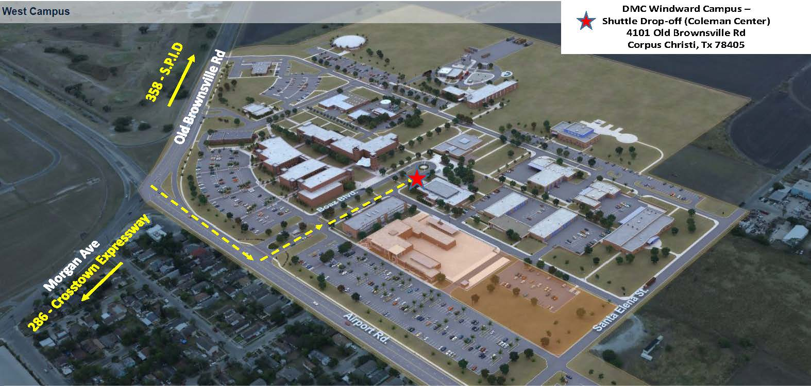

Del Mar Oso Creek Shuttle Drop Friday Only
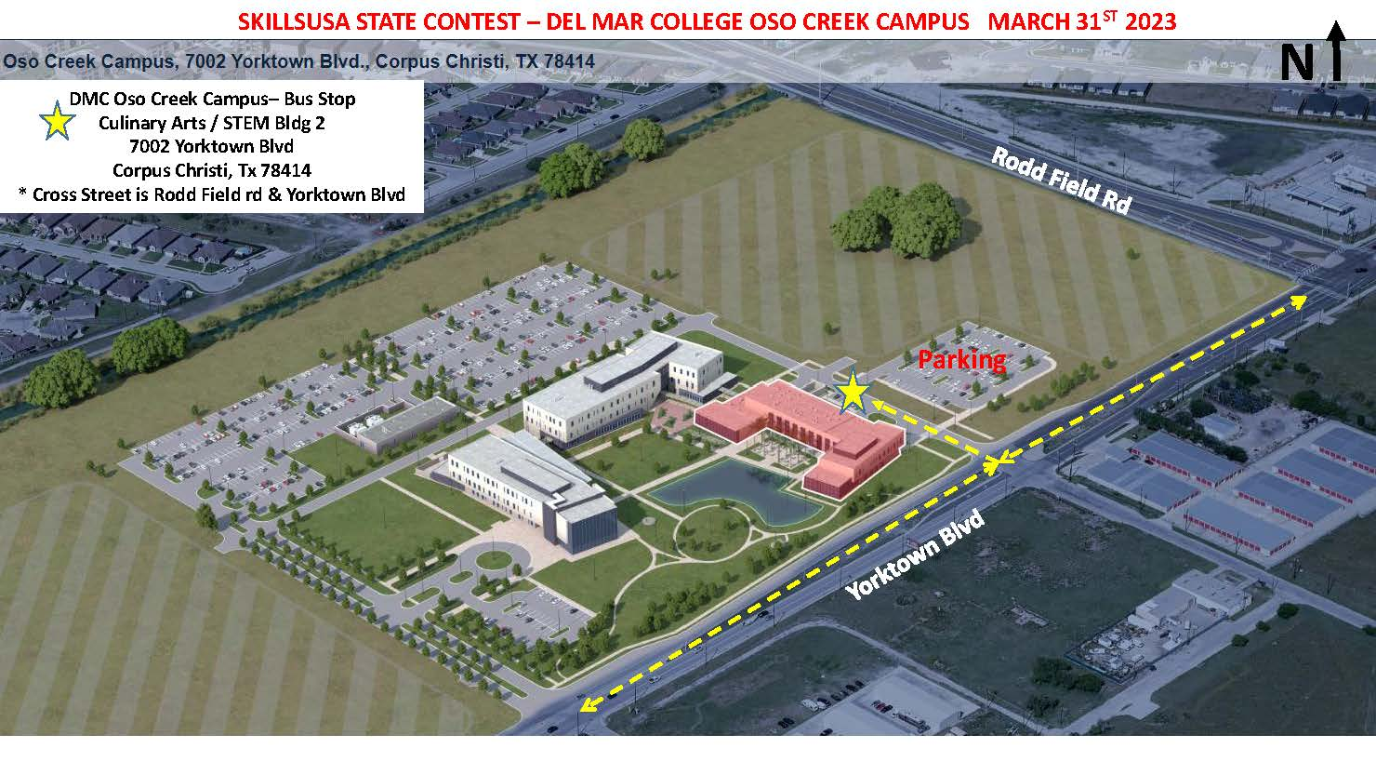
La Palmera Mall Shuttle Drop Friday and Saturday – exact spot TBD

