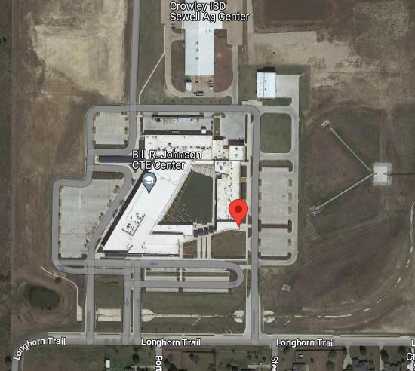
Cosmetology at Bill R Johnson District 4

- All schools should use the Main entrance
- Registration pick up and notebook drop off is at the Foyer to Cosmetology Hall – go to your right from the main entrance
- Parking is available at front entry
- Bring snacks/water for your students as no vending machines are available
- Please provide a lunch for your students that are in Barbering/Nailcare/Nail Art/ 3D Nail art/ Cosmo Quiz Bowl
- On site contacts: Shawndelle Harrington 806-470-7886 or Valerie Bell 682-804-3598
- Registration: Fri Feb 10 4-6p and Sat Feb 11 8a-8:30a

