District- Update 2023
Students will take a 50 question test related to Framework and scored on Final calculation of students contest score. Each question will be worth 1 point each.
SkillsUSA Framework The connection between the SkillsUSA Framework and SkillsUSA State Championships is imperative. The SkillsUSA Framework is used to pinpoint the Essential Elements found in Personal Skills, Workplace Skills, and Technical Skills Grounded in Academics. Students will be expected to display or explain how they used some of these Essential Elements. For more information, please visit www.skillsusa.org/about/skillsusaframework/.SkillsUSA Framework. The connection between the SkillsUSA Framework and SkillsUSA State Championships is imperative. The SkillsUSA Framework is used to pinpoint the Essential Elements found in Personal Skills, Workplace Skills, and Technical Skills Grounded in Academics. Students will be expected to display or explain how they used some of these Essential Elements. For more information, please visit https://www.skillsusa.org/about/skillsusa-framework/.

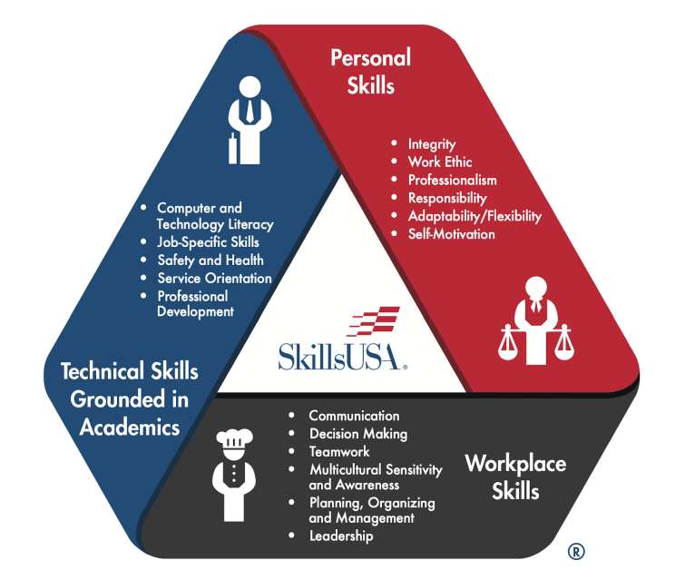

Competition Clothing: SkillsUSA Championships clothing requirements included in the technical standards have been established for the National Leadership and Skills Conference. The clothing classifications can be reviewed at https://skillsusa.egnyte.com/dl/zqBfetodFz .
Update: Kit checklist
These items listed are Competition Update
● Disinfectant jar (for implements with disinfection solution) ● One electrical outlet per competitor
● Pedicure basin with disposable liner ● Personal Resume - Hard Copy ● 1 - 8oz. Hand Sanitizer
● 1 - monomer, polymer and primer must be from the same manufacturer ● 1- Bonder Base Gel
● 4 - dapping dishes with covers ● 1 - Clean-It ● 1 – 25-50 ct. Clear Tips ● 1 - Tip & Repair Glue
● 1 - White Powder / clear or natural ● 1 - Pink Powder ● 1 - Adhesion Nail Liquid (Nail Glue)
● 1- Brush Cleaner ● 1 -Cuticle Oil ● 1 – Acrylic ● 1 - Lotion ● 1 - Cuticle Remover ● 1 - Polish Remover
● 1 - 20 - Forms ● 1 - Clean Finish Buffer ● 1 - Wipe-Its 25-50pk (nail wipes for gel)
● 1 - Plastic Manicure Brush ● 4 - File ● 3 - Buffers ● 2 – Shine buffers ● 1 – UV/LED Lamp
● 1– Manicure Light ● 1 - Bottled Water ● 1 – Red Polish ● 1 – Cleaner for gel nails
● All items necessary to complete a basic pedicure. Note: Implements should be brought to the competition ready to use (i.e., cleaned and disinfected, or new). Lotion, masks, scrubs and/or callus removers must be from the same professional manufacturer
● 1 – Towelettes for wiping brush ● 3 – small trash bag ● 2 – Safety glasses ● 4 – white towels
● Disposable towels for the table ● Paper towels ● You may also bring the following: acrylic paints, polishes/lacquers, colored powders (acrylic and dip), gel polish, rhinestones sizes 20ss and under, glitters and dusts, and adhesives, i.e., gel top coats/glue
● Portable kit organizer (to transport all items necessary for the competition)
● Manicure table lamp and electrical extension cord (optional)
SkillsUSA member -Student Model
Both contestant and model in SkillsUSA contest dress code (Panty hose not suggested for model)
Pencil
Extension cord
Table lamp (only if needed) (student will not be counted off)
Disposable trash bag for table and tape or way to attach
½ gallon of water
All items to complete pedicure on 1 foot (30min time frame)
All Items to complete a light cured gel set on human model hand (curing light needed)
1 hour time frame
All items to complete a set of sculpted acrylic nails on human model hand
1 hour time frame
All items to complete flat nail art on 1 hand and dark creme lacquer/polish on other hand
90 minute time frame
Contestants will have a folder/notebook with page protectors and a picture of each individual nail art. A typewritten description of the nailart theme. This notebook/folder will also include a resume for the contestant.
Contestant needs to be prepared to complete a 1-2 min mock nailcare consultation on the benefits of natural nail care. Read 5a under contest guidelines for more details.
Students will take a 25 question, multiple choice test over nailcare related material out of the cosmetology milady black book and salon fundamentals.
Please refer to nailcare Updates above for the list of supplies the contestant needs to bring.
The technical chair will only supply following at District:
*Table *chair *1 electrical plug.
Orientation will include the following:
*Kit check *Test *Oral consultation *notebook grade *uniform check *model needed for orientation.

