Scope of Contest
Contestants will be tested on skills required in the "front of the house" of a fine restaurant. The focus is sanitation, table set up, napkin folding, understanding the steps of service, and overall presentation. Students should wear the SkillsUSA Uniform with proper grooming & hygiene, follow ServSafe standards. These are evaluation areas.

Important Information
- Orientation attendance is mandatory.
- Menu will be provided at orientation.
- Specific table setting format will be provided prior to competition.
- Refer to National Technical Standards for contest detail and preparation for State/Nationals.

Contest Description
Task #1: Appearance/Uniform, Sanitation, Table-Setting, Napkin Folds (20 min) (30% of score):
- Table-setting: Set 3 formal place settings.
- Use ServSafe sanitization standards.
    - All settings must be identical.
- Napkin Folds: Competitors will create 6 unique napkin folds
  - 3 of the folds will be used as part of the table setting and the others will be set on an empty “seat” area on the table.
  - Napkin folds need to have labels with their proper names.
Task #2: Steps of Service (20 min) (45% of score)
      - Hosting: Competitor will host guest to table
      - Service: Competitors will serve 2+ courses to “guest(s)”.
    - Guest is not judge.
        - Menu will be provided the morning of competition.
        - Students will “serve” 2 courses from the menu to the guest using pretend food, but actual correct dishware i.e., soup in a bowl, salad on small place, etc...
        - Students will be expected to answer question(s) asked by the guest related to the menu.
          - Students are expected to perform all the steps of service.
      - Check Calculation: Using the “food” ordered by the guest to determine pricing, students will calculate a guest check, including tax and gratuity.
  - Form will be provided for standardization purposes.
  - Guest check should be filled out, just as if competitor were handing check to guest at a real restaurant.
  - Tax Rate 8.25%
  - Gratuity 18%
Task #3: Tableside item (15 min) (25% of score): Contestant Choice, choose 1 from the following list: Tableside Guacamole, Balsamic Vinaigrette, 3 Ingredient Omelet, or Tableside Caesar Salad (Choice is given so you can choose what is most available in your area.)
    - This is performed in a similar style to the Job Demonstration A contest.
    - Timeline: 3 min set up, 10 min presentation, 2 min clean up.
    - You will make the item from scratch in front of judge.
    - Mise en place should be completed prior to beginning competition.
    - Mise en place, sanitation, efficiency, and clean up are part of the score.
Scorecards
The National score sheets will be used to evaluate competitors

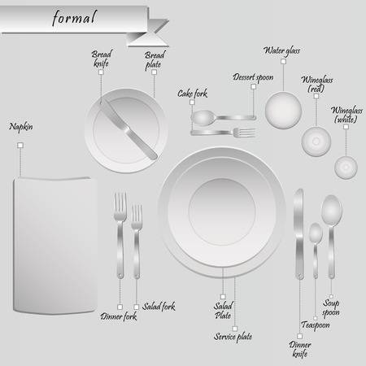
Table Setting Guideline:
The students will duplicate this place setting with the following exceptions:
- No service or salad plate will be used in the set up.
- Only 2 glasses; 1 water / 1 wine – water should be placed above the knife, not quite as far to the left.
- Napkin goes in the middle – where the 2 plates are in placed in the image
**This recipe is included as a sample only. Since you are providing the ingredients & mise, you can be creative in this area.
*Please see National Technical Standards for a comprehensive list of items needed for contest.

Tableside Item
- Make for 2 people
- Bring all ingredients for YOUR recipe, cut and in small containers ready for competition.
- Be creative and have fun with this part.
- Taste is no more than 25 points, the remaining points are showmanship, sanitation, and waste.

Supplied by State Technical Committee
Menu – will be given at orientation.

Service Equipment to be provided by CONTESTANT
- All ingredients necessary to create the Table Side Item. Ingredients can be premeasured.
- Bowl to mix ingredients, i.e, wooden bowl or other FOH mixing bowl
- Any utensils needed to create tableside item.
- Crumber
- Linen for Napkin Folds
- Calculator
- Any other items necessary to complete the scope of the competition. Examples: pens, polishing cloths, etc…

