SkillsUSA Texas

National Officer Application Process

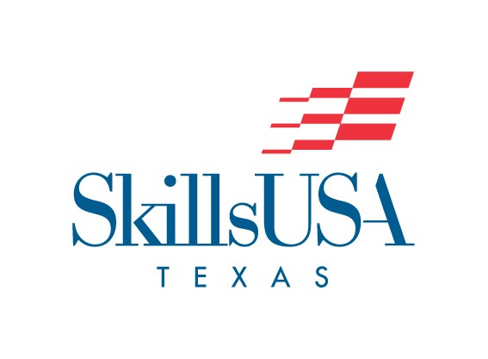

FILING DEADLINE: March 22, 2022 by 4:00PM

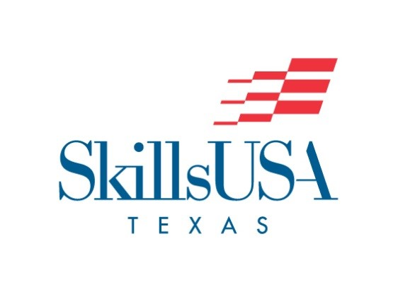

SkillsUSA Texas, “Champions at Work”

Thinking of becoming a National Officer?

Ask yourself the following questions:

- Can you explain, to a complete stranger (in professional dialogue), the purpose of SkillsUSA? Are you able to convey to others the way your program benefits our society?
- Will SkillsUSA be your top priority in your school and around the nation?
- Will you be able to miss 15 class days during the school year for SkillsUSA business and still maintain your grade point average?
- Are you willing to travel across the nation for leadership training and promotion of SkillsUSA?
- Will you be able to attend the SkillsUSA events indicated on the dates in the National Officer Program Guide?

SkillsUSA Texas will only endorse 2 candidates to run for National Office. The 2 candidates that Texas will consider endorsing will be announced at the SkillsUSA Texas Leadership and Skills Conference – Closing Award Session on: April 2, 2022. This announcement is not the official endorsement for National officer candidacy, but only a recommendation. National Officer candidates will officially announce their candidacy at the determined date outlined within the National Officer Program Guide.

The 2 Texas candidates that are announced at the SkillsUSA Texas Leadership and Skills Conference – Closing Award Session will need to officially apply to the Online Application process by May 15, 2022 by 4:00PM. Candidates will work with the SkillsUSA Texas State Office for endorsement letters and final application approval.

Prior to the SkillsUSA Texas Leadership and Skills Conference in April, SkillsUSA Texas members that are interested in running to represent Texas at the National level should complete the following items:

National Officer candidates should complete all information/forms required in the Preparation of Information and Application Components section (pages 16-20) of the 2022-23 National Officer Program Guide. The National Officer Program Guide can be found here: https://skillsusa.egnyte.com/dl/GZikSwTYn0

Scan and e-mail all completed information/forms, including the forms within this document, as one PDF document with signatures to:

contests@skillsusatx.org

Incomplete applications will not be accepted.

Application Timeline

• National Officer candidate Texas applications MUST be received by the filing deadline: March 22, 2022 by 4:00PM. After applications are received, officer candidates will be issued an access code to join the “officer candidate” course in Schoology. They will need either have an account or create an account for Schoology on their own.
• National Officer Screening tests will take place online: March 28, 2022 (online, assigned in Schoology)
• Any National Officer candidate that does not score above 85% on the Screening tests will NOT move on to the interview process.
• Any National Officer candidate that is scheduled for an interview MUST upload a high-quality headshot photo by March 30, 2022 (online, assigned in Schoology)
• National Officer interviews will take place on: March 31, 2022 (Interview schedules will be assigned in Schoology)
• The two National Officer candidates will be announced at the SkillsUSA Texas Leadership and Skills Conference – Closing Award Session on: April 2, 2022

PERSONAL DATA FORM

Candidate Name:
Age: Student Personal Email:
Date of Birth: Shirt Size: Pant Size: Shoe Size:
School: TX Chapter #:
School Telephone: School Fax:
Career Training Objective:
Enrolled in Program type:
Year in School: Date enrolled: Completion date:
SkillsUSA Advisor: Advisor email:
SkillsUSA Honors (offices held, awards received, etc.):

Other Honors (school, district, community, state & national):

Favorite hobbies, interests, and activities:

Names of local newspaper and radio, TV stations (need both names and addresses):
1.
2.
Parent/Guardian Name:
Address:
City, State, Zip Code:
Phone: Parent email:
Occupation: Cell phone:
Do you have any social media accounts? List ALL that apply (Facebook, Twitter, Instagram, any account where you would post information about SkillsUSA.):

Names of individuals and addresses who should receive copies of correspondence (Please include your advisor.):
1.
2.
3.
4.
Photography, Sound and Video Release

By my attendance at the conference at any SkillsUSA function, I hereby grant the SkillsUSA Texas Association permission to make still or motion pictures and sound recordings, separately or in combination, and also give a production company approved by the SkillsUSA Texas Association permission to use the finished silent or sound pictures, and/or sound recordings as deemed necessary.

Further, I so hereby relinquish to the SkillsUSA Texas Association all rights, title, interest in, and income from the finished sound or silent motion pictures, still pictures, and/or sound recordings, negatives, prints, reproductions and copies of the originals, negatives, recording duplicates and prints, and further grant the SkillsUSA Texas Association the right to give, sell, transfer and/or exhibit the same to any individual, business firm, publication, television station, radio station or network, or governmental agency, or to any of their assignees, without payment or other consideration to me.

My agreement to perform under camera, lighting and stated conditions is voluntary, and I do hereby waive all personal claims, causes of action, or damages against the SkillsUSA national headquarters and the employees thereof, arising from a performance or appearance.

Candidate Name (typed or printed)

Signature of Candidate Date

I have read and I understand the SkillsUSA, Texas Association State Officer Photography, Sound and Video Release. I agree to support the above-named student under these guidelines to the best of my ability:

Signature of Parent/Guardian Date

Signature of SkillsUSA Advisor Date

Signature of School Administrator Date

