SkillsUSA Texas
“Champions at Work”

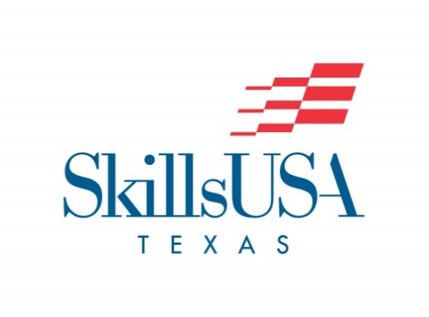

SkillsUSA Texas Special Called Meeting of the Board of Directors
Wednesday November 17, 2021, 4:30PM
Zoom Conference Call

- Call To Order
- Invocation
- Roll Call
- Board Approval for line of credit for Jake Lopez to be able to open a new Credit Card for SkillsUSA Texas use, allowing Janet Conner to close the account currently used.
- District budgets, t-shirts
- Computer upgrade for Bart
- Adjournment

